**Reasoning System ( for weather)**

**END TERM REPORT**

***By***

Ashish Roushan (20)

Ankursingh Kushwaha(21)

Shreya Ghosh (33)

Dipanshu Singh (34)



**Department of Intelligent Systems**

**School of Computer Science Engineering**

**Lovely Professional University , Jalandhar**

April – 2020

**Student Declaration**

This is to declare that this report has been written by us. No part of the report is copied from other sources. All information included from other sources have been duly acknowledged. We aver that if any part of the report is found to be copied, we shall take full responsibility for it.

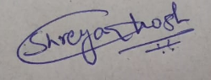

Shreya Ghosh

33



Ankursingh Kushwaha

21

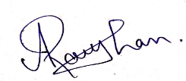

Ashish Roushan

20

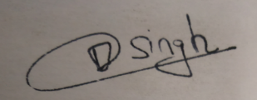

Dipanshu Singh

34

Place : Phagwara , Punjab

Date : 04/09/2020

**TABLE OF CONTENTS**

**TITLE PAGE NO.**

**1. Background and objectives of project assigned .......................................................... 1**

**1.1 ........................................................................................................................... 1**

**1.1.1 ......................................................................................................................... 3**

**1.1.2 ......................................................................................................................... 5**

**1.2 ............................................................................................................................ 7**

**1.2.1 .......................................................................................................................... 7**

**1.2.2 .......................................................................................................................... 9**

**1.2.3 ......................................................................................................................... 10**

**2. Description of Project ... ............................................................................................ 14**

**2.1 ............................................................................................................................. 17**

**2.2 ............................................................................................................................. 18**

BONAFIDE CERTIFICATE

Certified that this project report “……….REASONING SYSTEM FOR WEATHER……………..” is the bonafide work of “…………..Shreya Ghosh , Ankursingh Kushwaha , Ashish Roushan and Dipanshu Singh .…………” who carried out the project work under my supervision.

None

We carried it out on our own by ourselves

Background and objectives:

The reasoning is the mental process of deriving logical conclusion and making predictions from available knowledge, facts, and beliefs. Or we can say, "**Reasoning is a way to infer facts from existing data**." It is a general process of thinking rationally, to find valid conclusions.

In artificial intelligence, the reasoning is essential so that the machine can also think rationally as a human brain, and can perform like a human.

We have used deductive reasoning for the same, Deductive reasoning is deducing new information from logically related known information. It is the form of valid reasoning, which means the argument's conclusion must be true when the premises are true.

Deductive reasoning is a type of propositional logic in AI, and it requires various rules and facts. It is sometimes referred to as top-down reasoning, and contradictory to inductive reasoning.

In deductive reasoning, the truth of the premises guarantees the truth of the conclusion.

Objective: To reason according to a set of logical and objective standards, while subjective thinking refers to reasoning without objective standards. Objective reasoning means reasoning that is independent of the specific subjective context, not influenced by personal characteristics, feelings or opinions of the subject.

Description of project

Reasoning system on weather which allows us to enter a city and then our reasoning system provides us about the temperature, pressure, humidity and also gives us a vague description about the weather.

MODULE USED:

GUI:

The Graphical user Interface (GUI) is a form of user interface that allows user to interact with electronic devices through graphical icons and audio indicators such as primary notations, instead of a text-based user interfaces, typed command labels or text navigation. GUIs were introduced in reaction to the perceived steep learning curve of command-line interfaces, which require commands to be typed on a computer keyboard.

The actions in the GUI is usually performed through direct manipulation of the graphical elements. Beyond computers, GUIs are used in many handled mobile devices such as MP3 players, portable media players, gaming devices , smartphones and smaller households , office and industrial controls.

IMPLEMENTATION

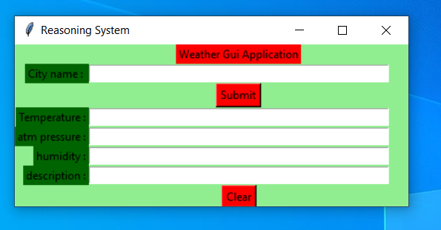

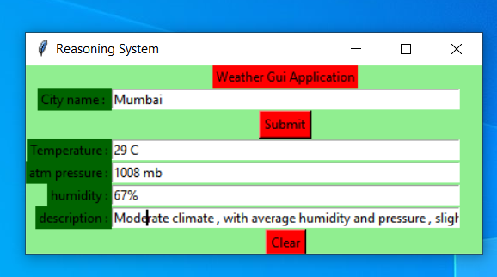

**Code :**

from tkinter import *

from tkinter import messagebox

# function to find weather details

# of any city using openweathermap api

def tell_weather() :

# import required modules

import requests, json

# enter your api key here

api_key = "Your_API_key"

# base_url variable to store url

base_url = "http://api.openweathermap.org/data/2.5/weather?"

# take a city name from city_field entry box

city_name = city_field.get()

# complete_url variable to store complete url address

complete_url = base_url + "appid =" + api_key + "&q =" + city_name

# get method of requests module

# return response object

response = requests.get(complete_url)

# json method of response object convert

# json format data into python format data

x = response.json()

# now x contains list of nested dictionaries

# we know dictionary contains key value pair

# check the value of "cod" key is equal to "404"

# or not if not that means city is found

# otherwise city is not found

if x["cod"] != "404" :

# store the value of "main" key in variable y

y = x["main"]

# store the value corresponding to the "temp" key of y

current_temperature = y["temp"]

# store the value corresponding to the "pressure" key of y

current_pressure = y["pressure"]

# store the value corresponding to the "humidity" key of y

current_humidiy = y["humidity"]

# store the value of "weather" key in variable z

z = x["weather"]

# store the value corresponding to the "description" key

# at the 0th index of z

weather_description = z[0]["description"]

# insert method inserting the

# value in the text entry box.

temp_field.insert(15, str(current_temperature) + " Kelvin")

atm_field.insert(10, str(current_pressure) + " hPa")

humid_field.insert(15, str(current_humidiy) + " %")

desc_field.insert(10, str(weather_description) )

# if city is not found

else :

# message dialog box appear which

# shows given Error meassgae

messagebox.showerror("Error", "City Not Found \n"

"Please enter valid city name")

# clear the content of city_field entry box

city_field.delete(0, END)

# Function for clearing the

# contents of all text entry boxes

def clear_all() :

city_field.delete(0, END)

temp_field.delete(0, END)

atm_field.delete(0, END)

humid_field.delete(0, END)

desc_field.delete(0, END)

# set focus on the city_field entry box

city_field.focus_set()

# Driver code

if __name__ == "__main__" :

# Create a GUI window

root = Tk()

# set the name of tkinter GUI window

root.title("Reasoning System")

# Set the background colour of GUI window

root.configure(background = "light green")

# Set the configuration of GUI window

root.geometry("425x175")

# Create a Weather Gui Application label

headlabel = Label(root, text = "Weather Gui Application",

fg = 'black', bg = 'red')

# Create a City name : label

label1 = Label(root, text = "City name : ",

fg = 'black', bg = 'dark green')

# Create a City name : label

label2 = Label(root, text = "Temperature :",

fg = 'black', bg = 'dark green')

# Create a atm pressure : label

label3 = Label(root, text = "atm pressure :",

fg = 'black', bg = 'dark green')

# Create a humidity : label

label4 = Label(root, text = "humidity :",

fg = 'black', bg = 'dark green')

# Create a description :label

label5 = Label(root, text = "description :",

fg = 'black', bg = 'dark green')

# grid method is used for placing

# the widgets at respective positions

# in table like structure .

headlabel.grid(row = 0, column = 1)

label1.grid(row = 1, column = 0, sticky ="E")

label2.grid(row = 3, column = 0, sticky ="E")

label3.grid(row = 4, column = 0, sticky ="E")

label4.grid(row = 5, column = 0, sticky ="E")

label5.grid(row = 6, column = 0, sticky ="E")

# Create a text entry box

# for filling or typing the information.

city_field = Entry(root)

temp_field = Entry(root)

atm_field = Entry(root)

humid_field = Entry(root)

desc_field = Entry(root)

# grid method is used for placing

# the widgets at respective positions

# in table like structure .

# ipadx keyword argument set width of entry space .

city_field.grid(row = 1, column = 1, ipadx ="100")

temp_field.grid(row = 3, column = 1, ipadx ="100")

atm_field.grid(row = 4, column = 1, ipadx ="100")

humid_field.grid(row = 5, column = 1, ipadx ="100")

desc_field.grid(row = 6, column = 1, ipadx ="100")

# Create a Submit Button and attached

# to tell_weather function

button1 = Button(root, text = "Submit", bg = "red",

fg = "black", command = tell_weather)

# Create a Clear Button and attached

# to clear_all function

button2 = Button(root, text = "Clear", bg = "red",

fg = "black", command = clear_all)

# grid method is used for placing

# the widgets at respective positions

# in table like structure .

button1.grid(row = 2, column = 1)

button2.grid(row = 7, column = 1)

# Start the GUI

root.mainloop()

SWOT ANANLYSIS:

Strength :

All our team members are efficient in coding and we were able to code together and get the result and implementations as shown above

Weakness:

The creative thinking process was lacking in us , and we were’nt able to make it a fancy application as thought

Opportunities :

This can help in knowing about the weather all over the world by just clicking the name of the city , along with its description

Threat :

It’s an evolving generation , and there can be someone who can make a better version than ours.